Preschool 1 2 & 3
Sunday | Monday | Tuesday | Wednesday | Thursday | Friday | Saturday
 |  |  |  | 1 | 2  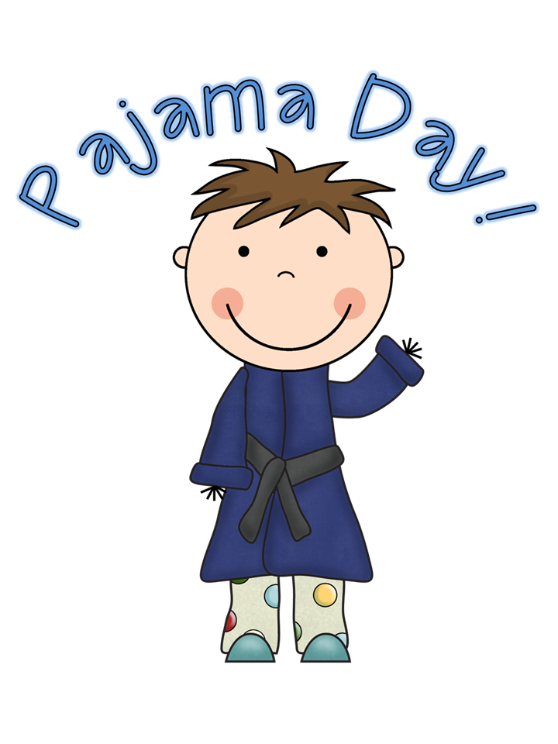 | 3
4 | 5 | 6  Scavenger Hunt | 7 | 8 | 9  Show and Share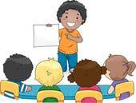 | 10
11 | 12 | 13  Face Painting | 14 | 15  Let’s Do Yoga  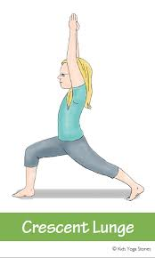 | 16 | 17
18 | 19  Show and Share | 20 | 21 | 22 | 23  Jersey Day  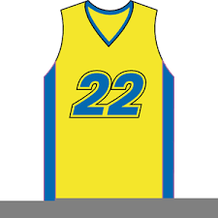 | 24
25 | 26 | 27 | 28 | 29 | 30  Let’s go for a walk